Faculty of English Language and Linguistics
Dean: Assoc. Prof. Dr. Nguyen Mai Dang
About the faculty: We train students to use English with confidence and to work in a global environment. Our programs combine strong language skills, practical experience, and career-focused knowledge.

Undergraduate Programs

Major 1: Teaching methods
- Introduction: This major prepares future English teachers. Students learn how to plan lessons, manage classes, and use modern teaching methods.
- Highlights:
  - Practical training in real classrooms
  - Modern teaching techniques and technology
  - Skills for teaching all age groups
- Credits: 140
- Duration: 3.5 years of study + 0.5 year of internship and thesis
- Objective: Graduates will have strong English skills, good teaching methods, and the ability to keep learning and improving.
- Career prospects: Graduates can work in primary, secondary, and high schools, and in local and international education centers. They can also work in international schools, skills-training centers, and global education organizations.

Major 2: Management Studies
- Introduction: This major combines English with business and management knowledge. Students learn to work and communicate well in international workplaces.
- Highlights:
  - English used in real business situations
  - Teamwork, leadership, and communication skills
  - Internships in companies and organizations
- Credits: 140
- Duration: 3.5 years of study + 0.5 year of internship and thesis
- Objective: Graduates will use English effectively in management and be ready for multicultural, international workplaces.
- Career prospects: Graduates can work in the media, radio, and television, and in local or foreign companies. They can also join education groups, domestic and international projects, travel companies, hotel groups, and resorts.

Major 3: Translation & Interpretation
- Introduction: This major trains students to translate written texts and interpret spoken language between English and Vietnamese, accurately and professionally.
- Highlights:
  - Practice in translation and interpreting (consecutive and simultaneous)
  - Wide knowledge of culture, society, and specialized topics
  - Real translation projects and practice sessions
- Credits: 140
- Duration: 3.5 years of study + 0.5 year of internship and thesis
- Objective: Graduates will translate and interpret with high accuracy and understand different cultures well.
- Career prospects: Graduates can work in diplomatic agencies and embassies, in local and foreign companies, and in international corporations. They can also work in the press and media, publishing houses, and television, or teach English in schools of all levels and language centers.

Sample Syllabus by Semester
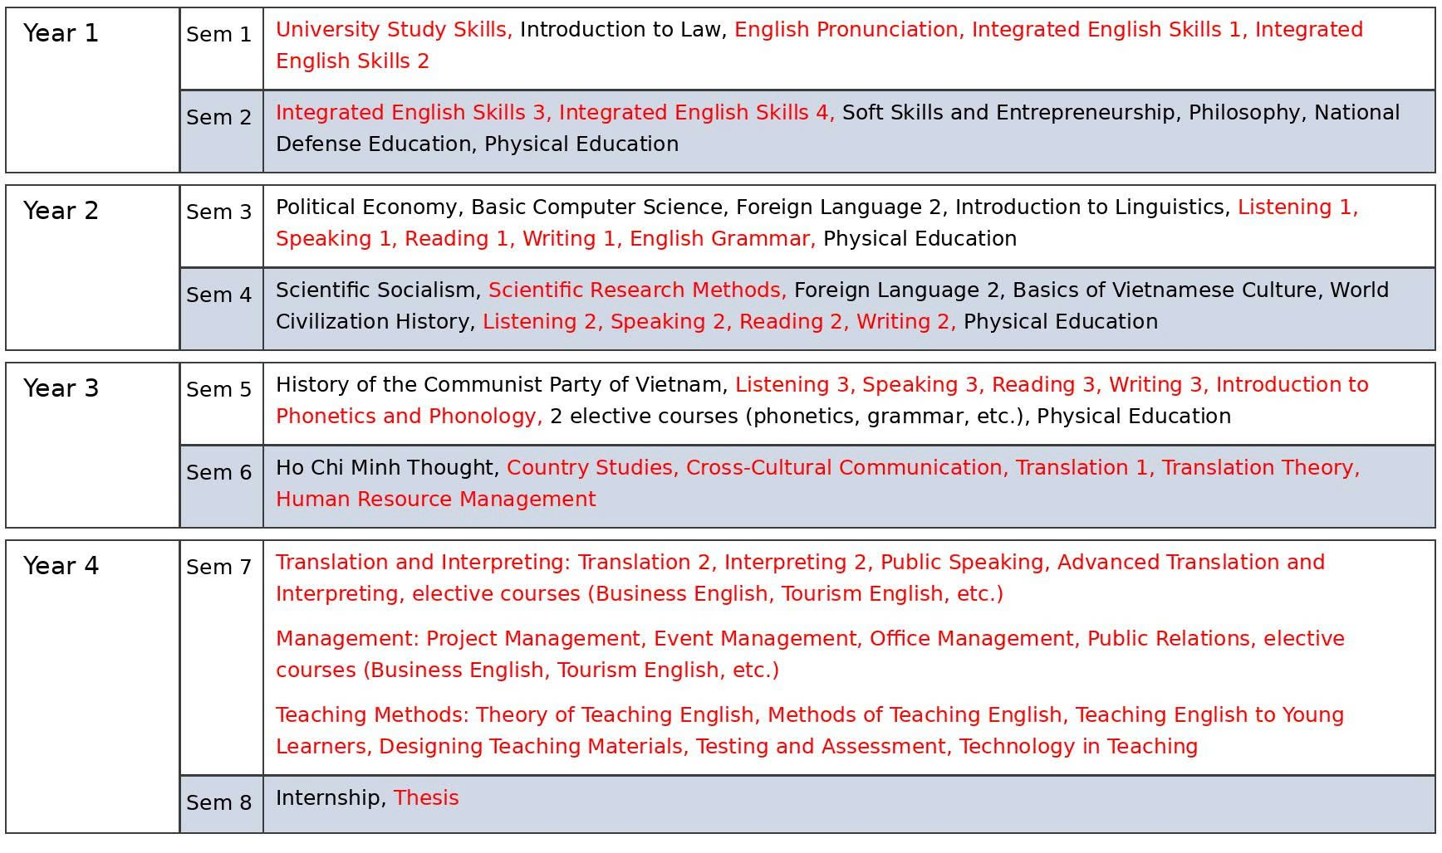

Photos
- Conferences, seminars, student research projects
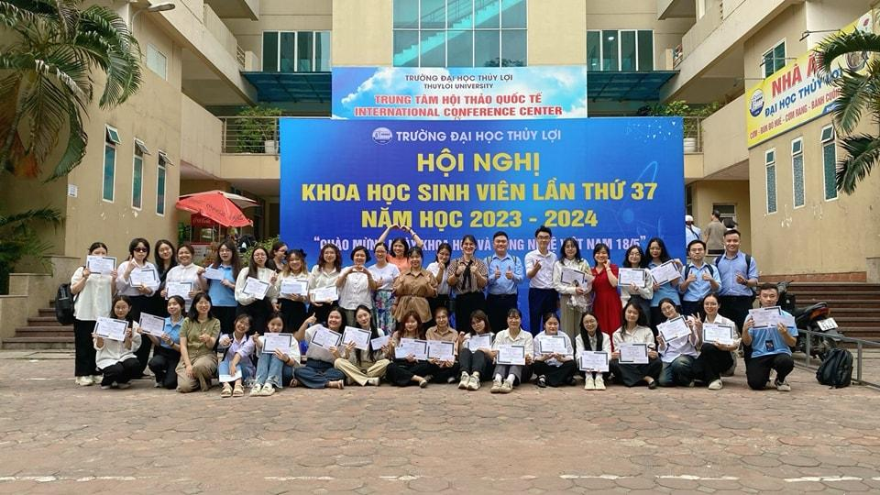
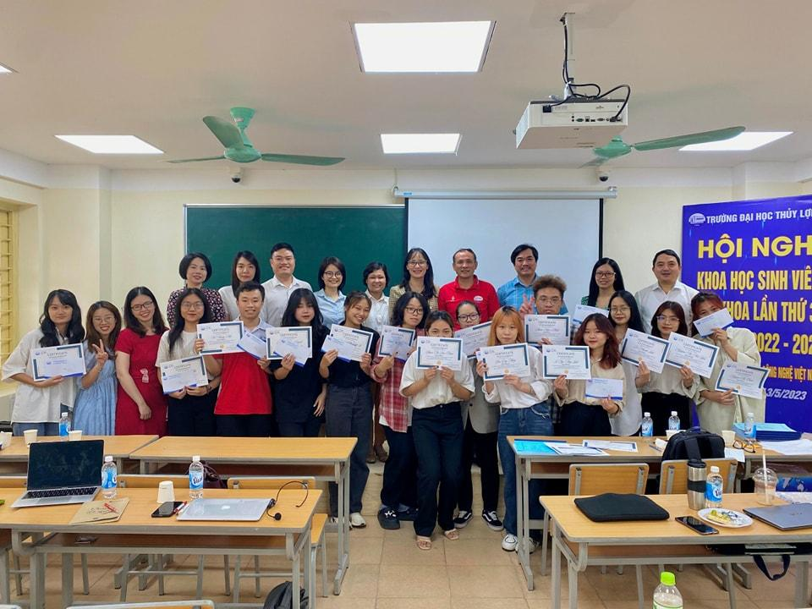
- Training Programs, classrooms, practice sessions, internships
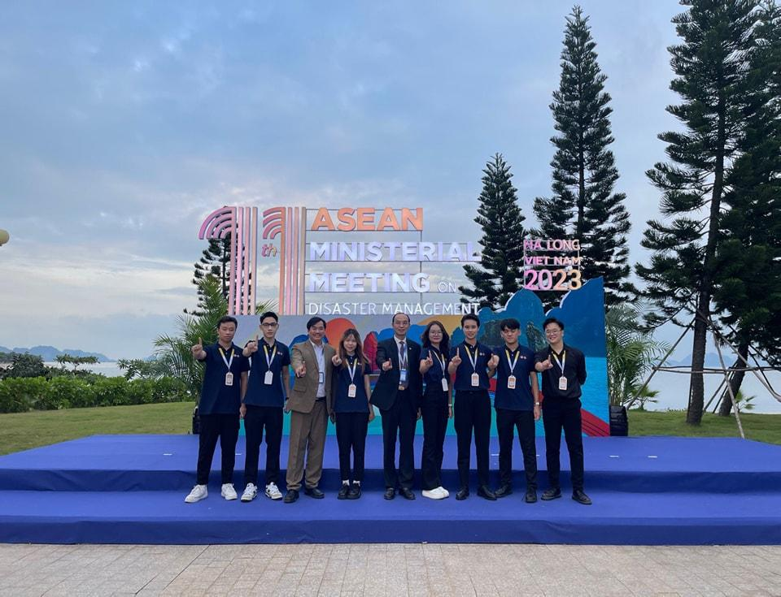
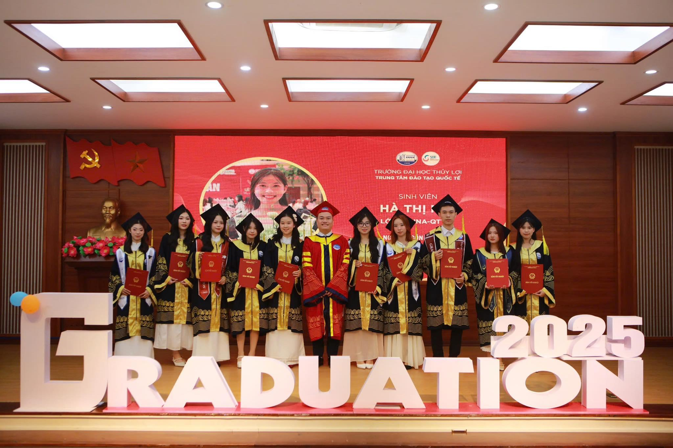
- Lecturers / students / faculty activities

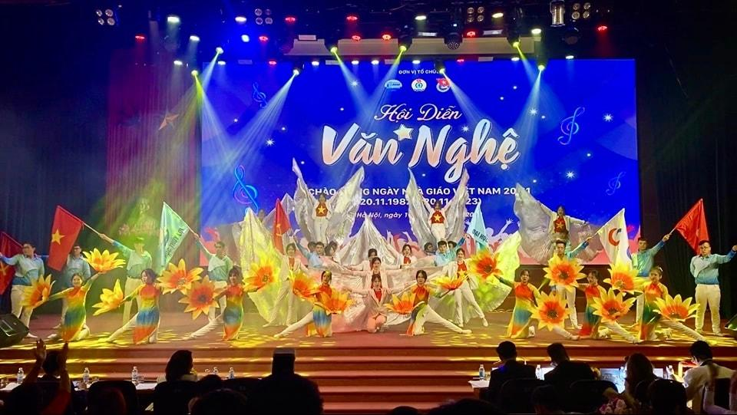

Contact
- English Language and Linguistics, Thuy Loi University
- Address: 175 Tay Son, Kim Lien, Hanoi
- Website: https://tlu.edu.vn/

